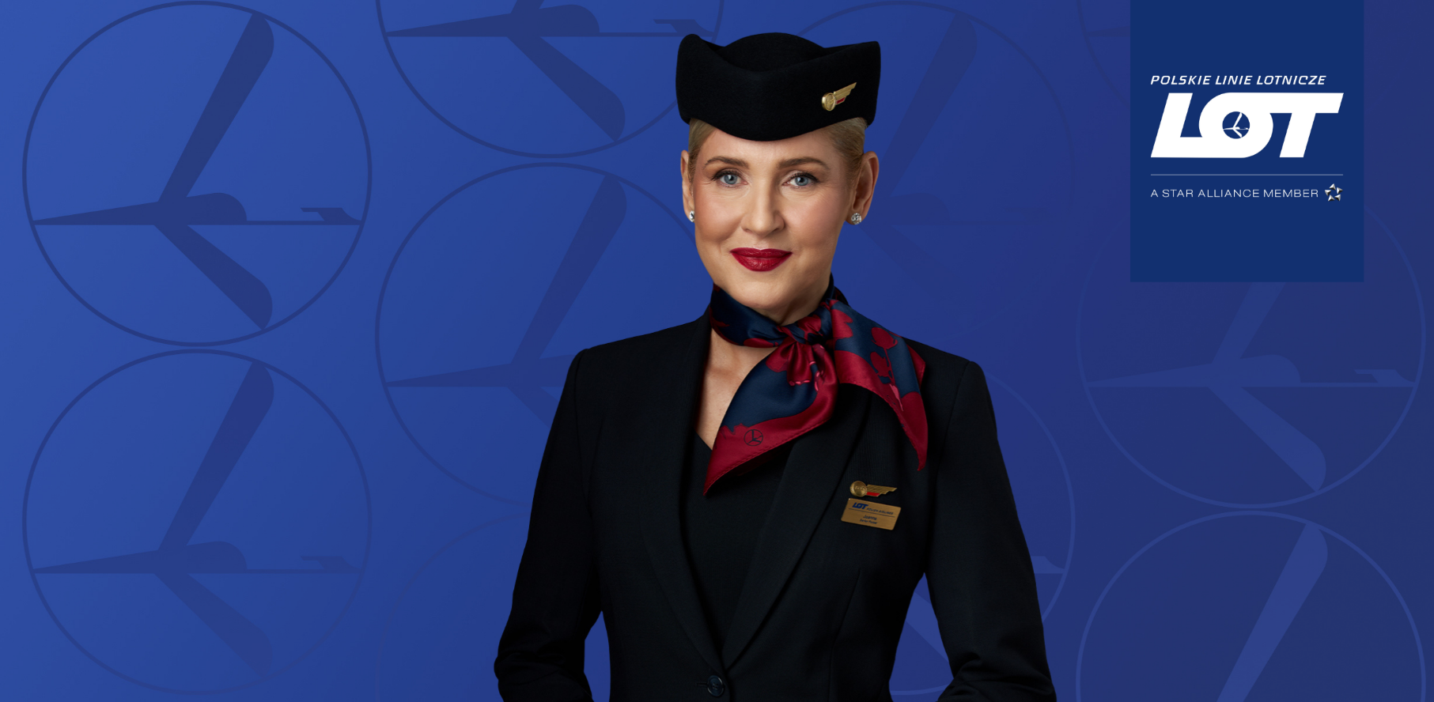

Dear Partners,
We would like to kindly remind you that, effective May 4, 2026, significant changes to the distribution of airline tickets will come into effect. Their purpose is to further develop the offer within the NDC channel, making it more transparent and better aligned with current distribution trends.
We encourage you to read the key information on this topic below.
- Withdrawal of the No-BAG fare from EDIFACT:
The list of routes where No-BAG fares will be withdrawn will be expanded to include the following connections:
- from Armenia, Albania, Montenegro, Croatia, Cyprus, Iceland, Malta, Sweden, Spain and Portugal to Poland
- from Poland to India
- from Poland to all short-haul markets, except Lebanon, Israel, Egypt, Saudi Arabia, the United Arab Emirates, Morocco and Turkey

- Introduction of the No-BAG fare in NDC and on LOT.COM:
The No-BAG fare will be added to LOT’s offer in the NDC channel and on LOT.com for routes from India to all destinations across Europe.
At the same time, the YR fee remains unchanged and amounts to EUR 16 / USD 17 / PLN 69.
More on LOT Open Connect
If you have any questions or require additional information, please contact the sales representatives of LOT Polish Airlines.
Thank you for your partnership,
LOT Polish Airlines Team

LOT Open Connect partners:
